AE 4342 – Lab 6

**What is the mass ratio for each of the three burns?**

Equation is: $\frac{m_{i}}{m_{f}}=e^{\frac{Δv}{I_{sp}g_{o}}}$

Isp = 350s

go = 9.81

Burn 1 $Δv$ = 250m/s

* Mass ratio = 1.0755

Burn 2 $Δv$ = 200m/s

* Mass ratio = 1.0600

Burn 3 $Δv$ = 500m/s

* Mass ratio = 1.1568

**Table on next page**

**What is the percent mass margin? Is the mass margin too high, too low, or about right given the fidelity of your analysis? Explain why.**

Mass margin = 100*1006.14/3250 = 31%

The mass margin of 31% is about right assuming the project in is pre-phase A or phase A, as projects should keep between 25%-35% at that stage of the project lifecycle, as derived from previous mission in LEO. The analysis has good fidelity however it could be improved by adding further subcomponents under each of the spacecraft bus main components. The fidelity could also be improved by increasing amount of iterations, however, 100 iterations seems to be enough for this MBS.

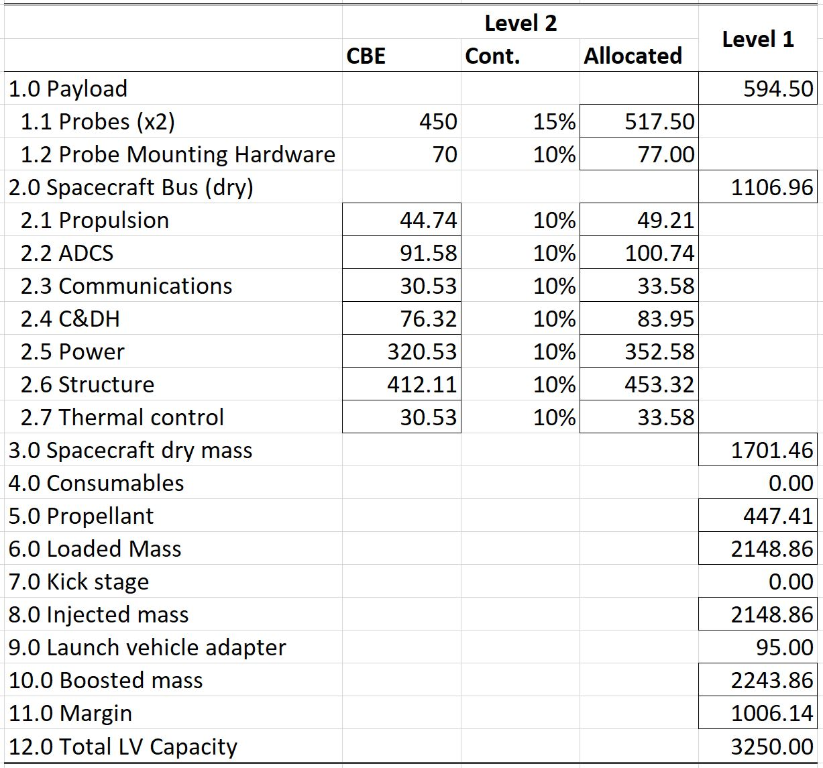

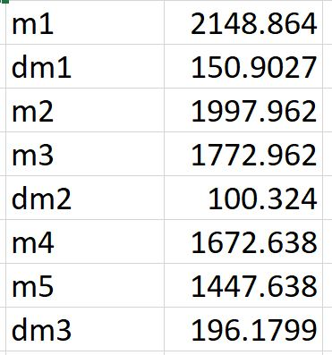

Table of vehicle mass and amount of fuel used between each stage of the mission